# Image patch experiment 2: Inquisit Verison for M-Turk

1. Experiment Procedure

In this experiment, each participant complete 40 experiment trials, followed by a survey measuring schizotypy traits.

In each experiment trial, a fixation cross will be presented in the center of the screen for 500ms, followed by a big Image will be presented for 133ms. Then, the image will be masked. Participants are then asked to answer accompany 6 questions, where each question prompts them to judge if a small image patch was part of the big image or not. These patches include 2 patches from the presented image but without the critical object, 1 patch containing the critical object (original/modified, 50/50 chance) and 3 absent patches.

Scripts Description:

* BaseScript_B1_Gx.iqx

This Script created by an .m file named ‘BaseScriptCreate.m’. It contains the relevant info of the experiment stimuli. For example:

List of Image filenames:

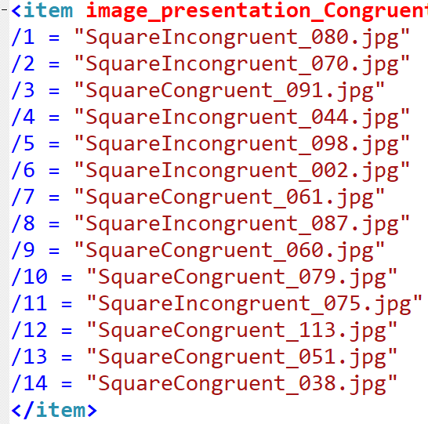

List of critical patches in corresponding order

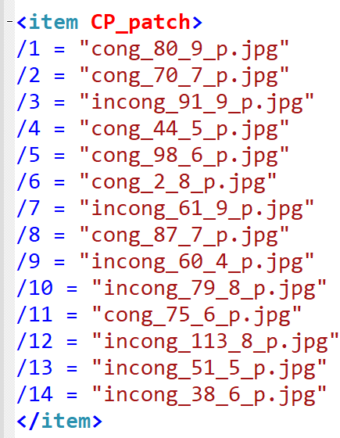

positions of the critical object patches:

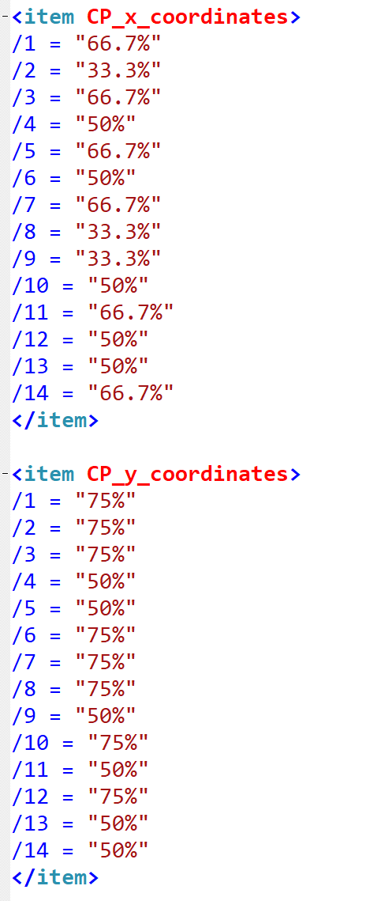

And so on.

* Script_B1_Gx.iqx

This script is used to start the experiment. It includes all files the experiment needs.

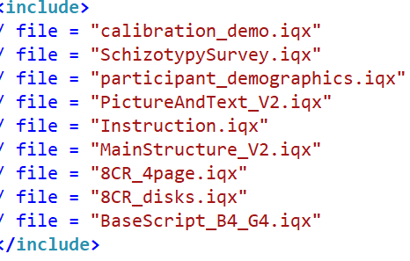

* MainStructure_V2.iqx

The main body of the experiment. It contains the strategy of trials present and collect correspond data:

Fixation Step:

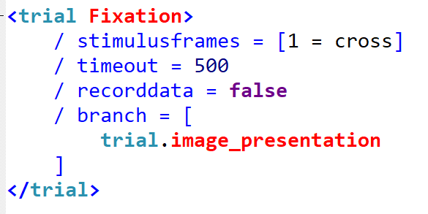

Image Presentation Step:

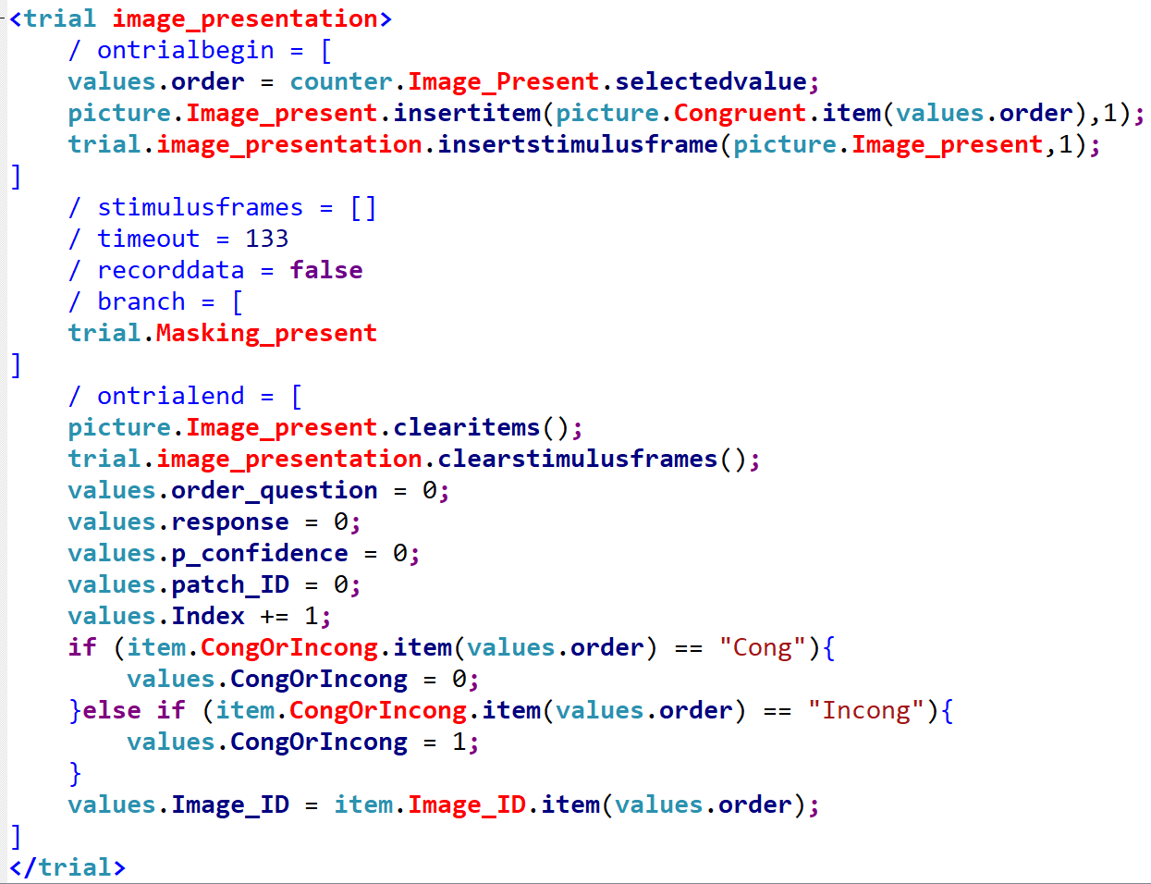

Masking (Big Image) Step:

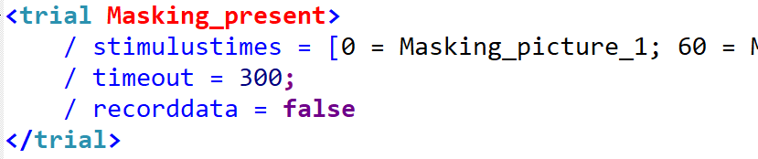

Patch Presentation Step: see “trial.Patch_present” section in “MainStructure_V2.iqx”

Masking Step (Patch)

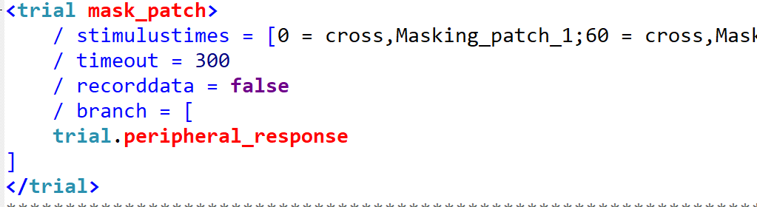

Response Page and Re-centre cursor:

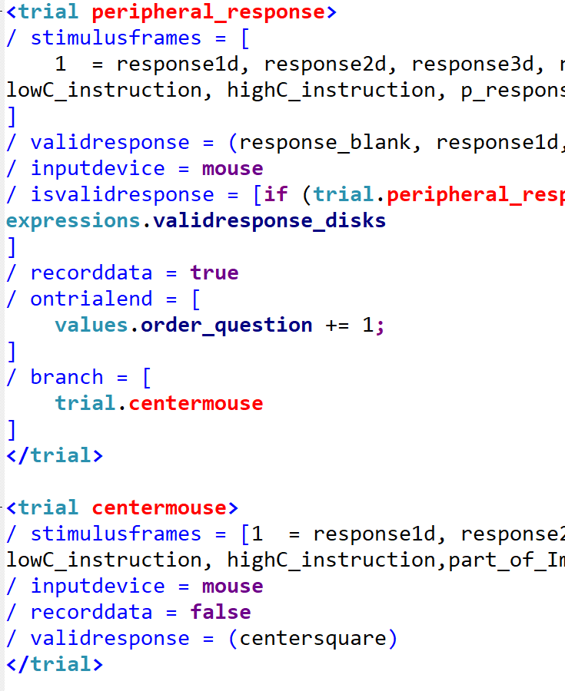

* PictureAndText.iqx

This file contains most of <picture> and <text> syntax which used in the ‘MainStructure.iqx’

* InstructionPage.iqx

Contents for Instruction Pages

* calibration_demo.iqx

Contents for Calibration pages

To avoid the influence of differences in participants’ screens, we want to keep the same viewing size across participants.

When a person keeps his/her arm straight, the visual angle of his thumb and eyes is 2 degrees. There will be a line shown on the screen as reference line. Subjects adjust their head position until they see their thumb has the same width of that line. Then they are asked to keep this position throughout the experiment.

On top of that, we went through further calibration procedures, to obtain their screen resolution and distance from the screen.

* SchizotypySurvey.iqx

A survey measuring the schizotypy traits of the participants – this part is for another student’s project.

1. Strategy

* Randomly-select stimulus in each trial

In each session, we randomize the presentation order of images listed in the base scripts. We also randomize the sequence of patches in each trial, using a counter which choose from 1 to 6 (counter 1), and another counter choosing from 1 and 2 (counter 2):

When counter 1 = 1 and counter 2 = 1: the patch will be an original object patch

When counter 1 = 1 and counter 2 = 2: the patch will be a modified critical patch

When counter 1 = 2 or 3: patch from the image, without the critical object

Counter 1 = 4-6: absent patch.

* Trick on patch presentation

In the beginning, I copy all small patches which may be used in each experiment file. But this makes the codes very complicated, and the file is too big to upload on Mturk. Then I use a trick to reduce the number of patches you need to contain in the file.

For the patched comes from the original image, instead of showing the correspond patch individually, we show the present big picture and a particular same size .png picture which has part of transparent in particular position.

For example:



+ =

The cover picture has the background colour.

So in this method, the patches comes from present image for all trials can use 9 different png pictures to replace. Highly reduce the size of the file and time to prepare the experiment online.

* Patch Location Coordinate:

|  |  |  |
| --- | --- | --- |
| 33.3%,25% | 50%,25% | 66.7%,25% |
| 33.3%,50% | 50%,50% | 66.7%,50% |
| 33.3%,75% | 50%,75% | 66.7%,75% |

These coordinates values only feasible when the present image size set to 75%. If size has been changed, these values need to calibration again.

* Matlab files operate order:

Firstly, run the ‘BaseScriptCreate.m’ to create base list files.

Secondly, run the ‘IncludeOrderCreate.m’ to create start scripts

At last, run the ‘CopyFiles.m’ to create individual experiment files.

They are located in the folder named ‘WebVersion’

* To run a short demo of the experiment (20 experiment trials, taking ~20 mins to complete), follow this link: <https://mili2nd.co/vbvb>

1. Tips

Online test can’t have nested folders. You need to put all files and scripts into the same folder and then upload online.

Some syntax may cause an unexpected problem when you do the online test. Even you find it correct on your own laptop.